QUESTION 1
A)
Search is the process of exploring a problem space to find a sequence of actions (a path) leading from an initial state to a goal state.
Feature | Informed Search | Uninformed Search
Definition | Uses additional knowledge (heuristics) to guide the search | Searches without any extra knowledge about the goal
Decision Basis | Chooses nodes based on estimated closeness to goal | Chooses nodes based only on search structure
Heuristic Function | Uses h(n) or evaluation functions | Does not use heuristics
Speed | Generally faster | Usually slower
Efficiency | More efficient in large problems | Less efficient
Nodes Explored | Fewer nodes | More nodes
Memory Usage | Can be lower due to focused search | Often higher because many nodes are explored
B)
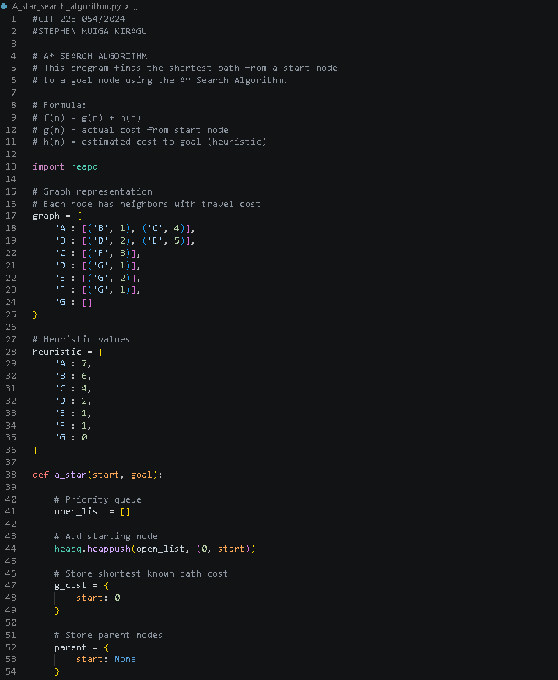
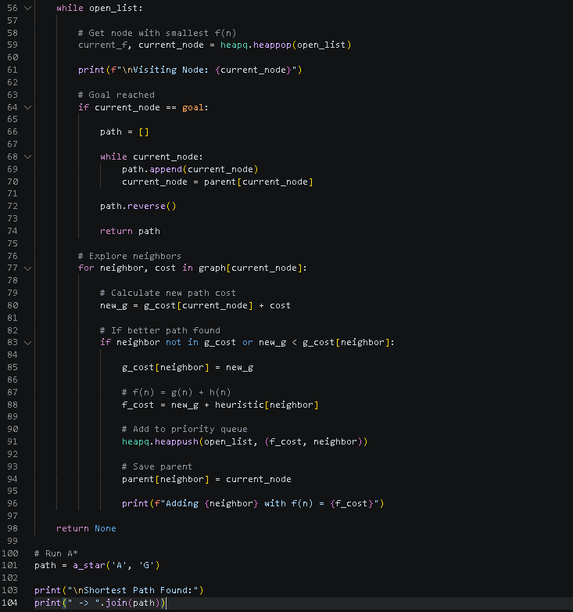
C)
i)
Concept | Meaning | Condition | Example
Valid | A statement that is true in all possible interpretations | Always true | P∨¬P
Satisfiable | A statement that is true in at least one interpretation | Can be true sometimes | P∧Q
Unsatisfiable | A statement that is false in all interpretations | Never true | P∧¬P
Falsible | A statement that is false in at least one interpretation | Can be false sometimes | P→Q

ii)
P Q R P∧Q ¬R P∧Q → ¬R
T T T T F F
T T F T T T
T F T F F T
T F F F T T
F T T F F T
F T F F T T
F F T F F T
F F F F T T

- The formula is not valid because it is false on one row. It must be true on all rows
- The formula is satisfiable because it is true on 7 rows
- The formula is not unsatisfiable because only one row is false. It must be false on all rows
- The formula is falsifiable because it’s false on only one row.

QUESTION 2
A)
PEAS
Element | Description
Performance | Accurate victim identification, fast processing time, low error rate, secure data handling, high matching accuracy, efficient storage of genomic data
Environment | Mortuaries, forensic laboratories, hospitals, DNA databases, government identification systems, relatives providing DNA samples
Actuators | DNA sequencing machines, robotic sample handlers, database update systems, automated reporting systems, alert/notification systems
Sensors | DNA scanners, biometric readers, barcode readers, sample collection devices, laboratory sensors, genomic analysers

PAGE
Percepts | DNA sample data, genomic sequence readings, sample quality indicators, family DNA profiles, laboratory status information
Actions | Analyse DNA sequences, compare genomic patterns, identify probable matches, generate reports, update databases, notify authorities
Goals | Correctly identify victims, reduce identification time, improve forensic accuracy, assist investigations, maintain secure records
Environment | Forensic labs, hospitals, DNA databases, government agencies, disaster recovery centres, mortuaries
2B)
